**Assignment No. 16**

**Manage Amazon DNS service and run a project using domain-name and URL**

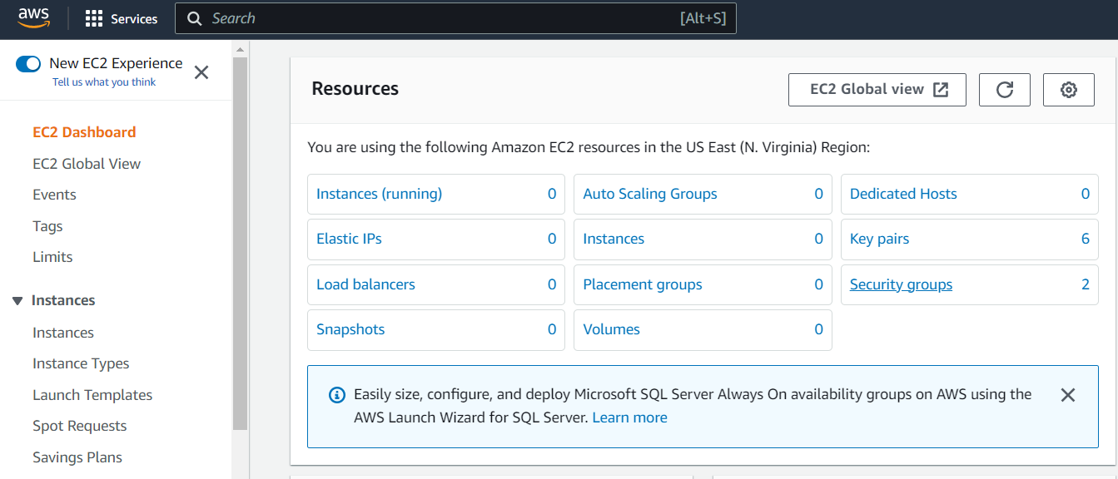 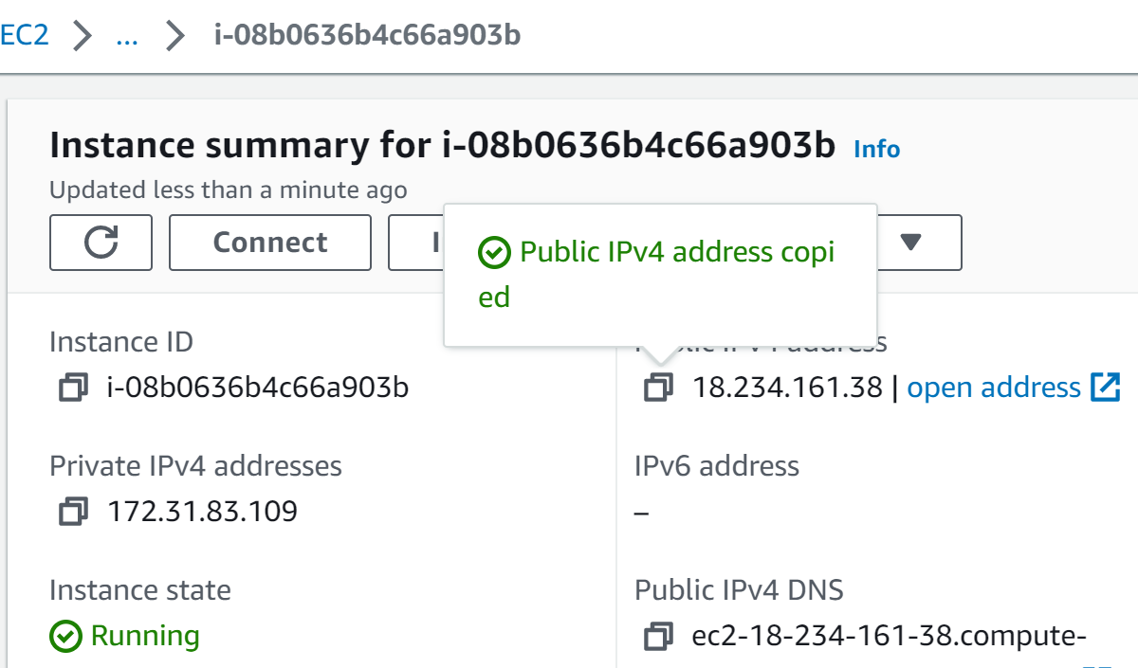

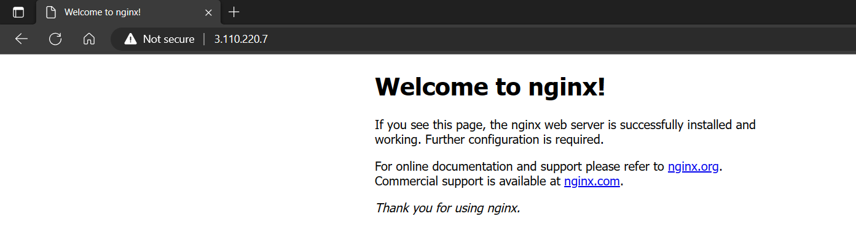 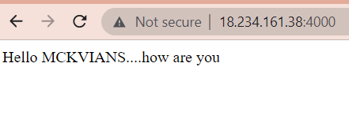

**6. Our EC2 instance works as intended. However, to access the webpage one always requires the public IPv4 address of the server instance which is very complicated/less accessible for end-users of our webpage/web application. To make it easier for our end-users, we need to bind a domain name to the server instance so that anyone can use the domain name and the URL to access the project.**

**Now Search “Route 53” in the search bar of AWS console and click on “Route 53”**

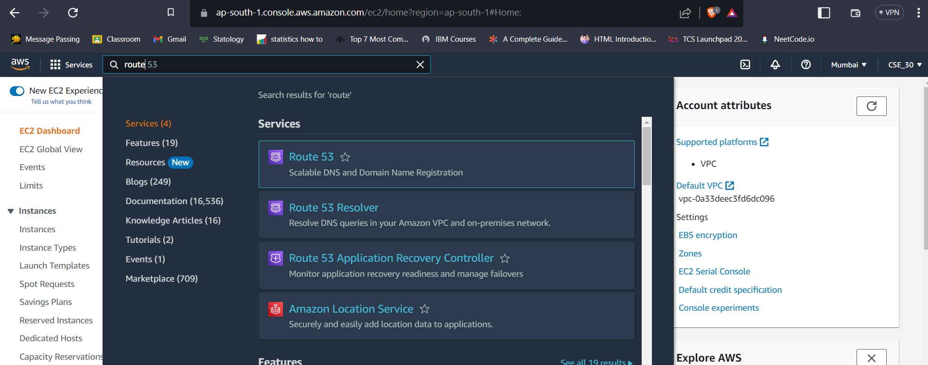

1. **Visit** **aws.amazon.com** **and Sign in.**
2. **Go to EC2 Service**
3. **Create an instance with custom security group and user data.( As done in Assignment 10)**
4. **Click on the instance and copy the public IPv4 address and paste in the browser.**
5. **Check accessibility of project by appending port number after the public IPv4 address.**

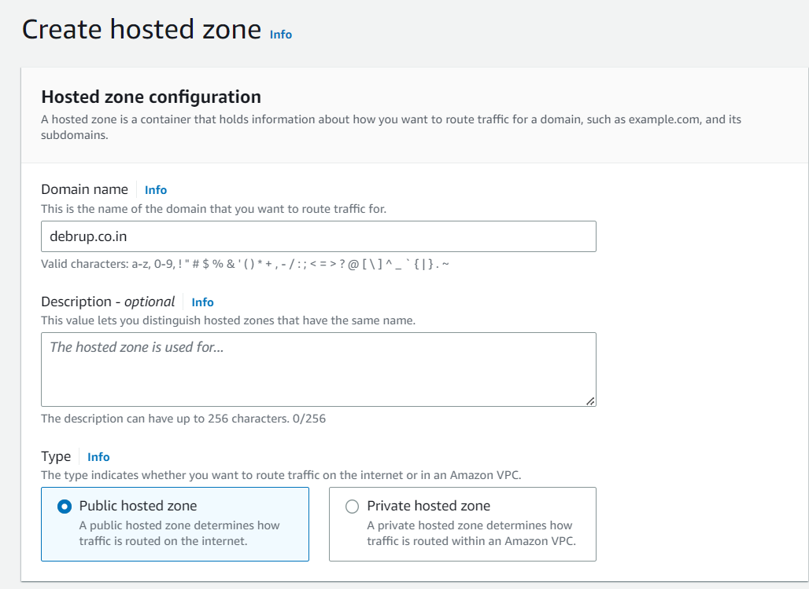 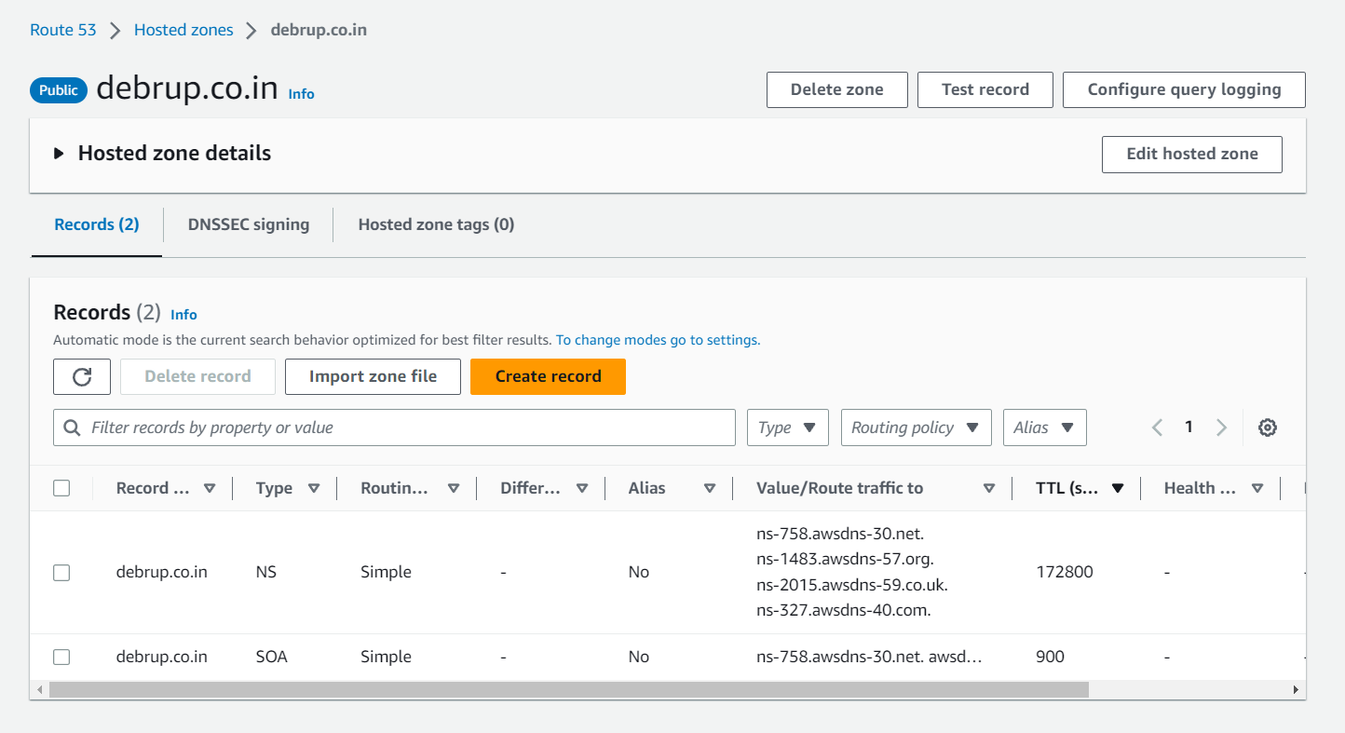

**s**

**7. We require a registered Domain name for this assignment. So, after obtaining one (free or paid) go to the Webpage of your Domain provider and log-in to your account where you can find all the details of your purchased Domains.**

**This may vary from site to site, so you will have to do this based on what site you are using.**

**We (for now) will be using GoDaddy.com, because we have purchased a Domain from them.**

**8. In the Route 53 dashboard “Click on “Create Hosted Zone button”.(** **Alternatively, you can go to hosted zones from the left-side bar and then select create hosted zone option.)**

**9.** **Now, copy your Domain name from your Domain providers website. Here we used GoDaddy.com. Paste the domain name in the given field in Hosted Zone configuration page.**

1. **Click on “Create Hosted Zone”.**
2. **Click on “Create a record button”.**

1. **Need not to give any name. Keep the record name blank and record type as it is.**
2. **Under the value, copy and paste your server instance public IPv4 address which you want to route to using your DNS.Then click on create records button**

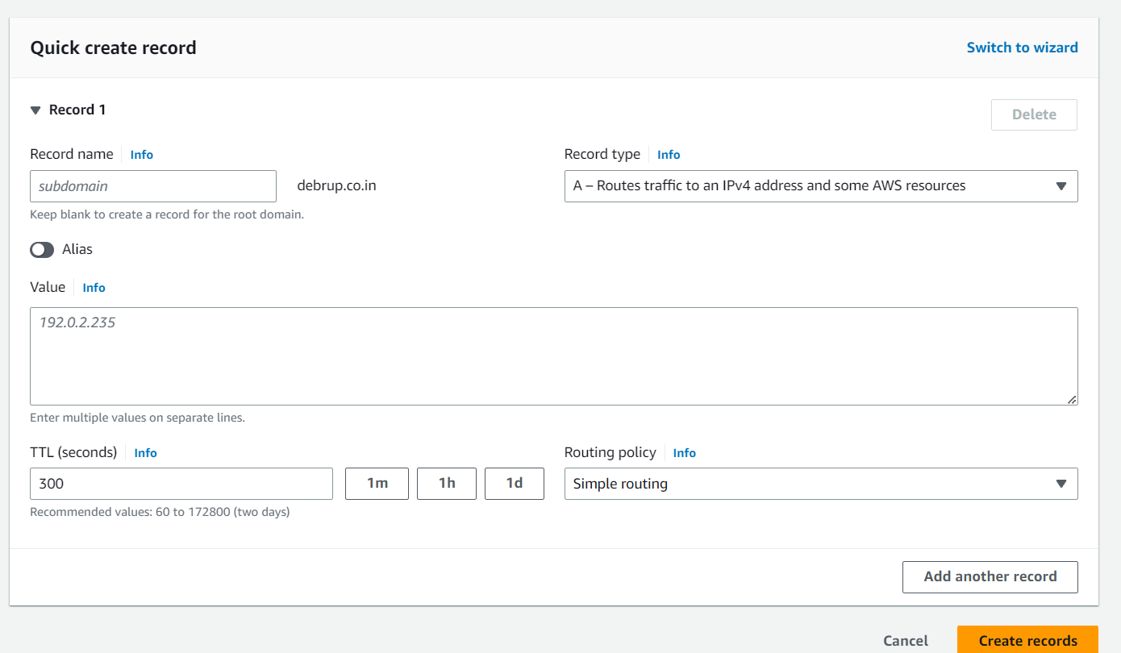

1. **Click on the Create Record button again.But this time give the record name as “www”. Select Record type as CNAME. In the text box under value, write the full domain-name there. (For example: example.com). Click on “create records”.**
2. **Now select the record with type nameserver (NS) .( The values seen on the right-hand side are required for the next steps.)**
3. **Now go to your Domain providers webpage. Go to your purchased Domains settings.**
4. **Click on DNS section. (This may vary from provider to provider)**
5. **Click on the nameservers option.**
6. **Click on the Change nameservers and add here all the values opened in the Route 53 page.Select use my own nameservers option.Add nameservers.Then click on “Save”.**

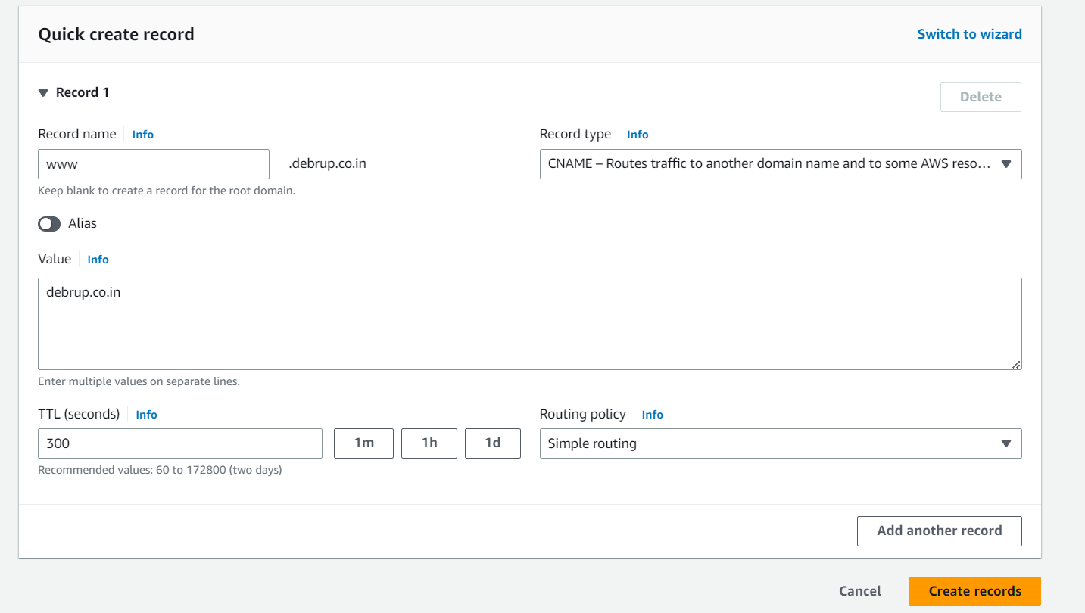 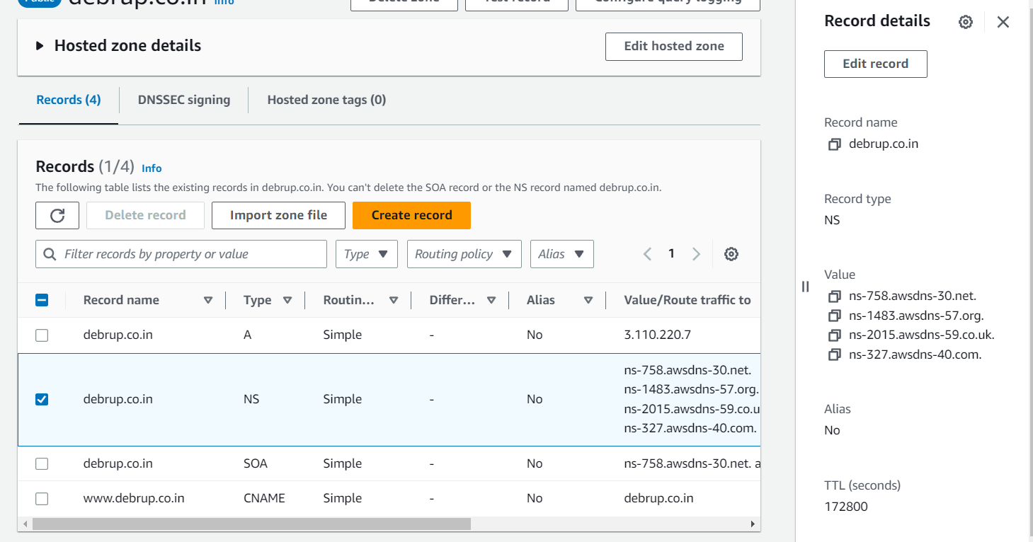

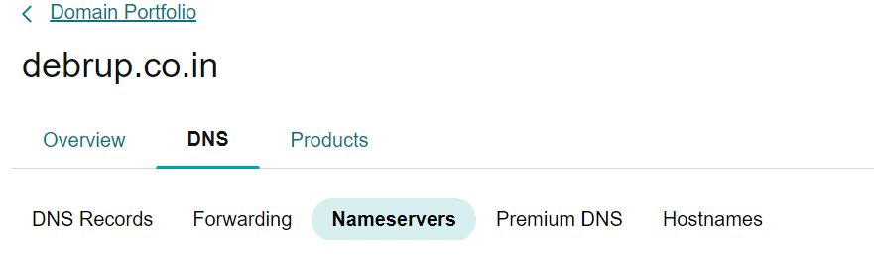 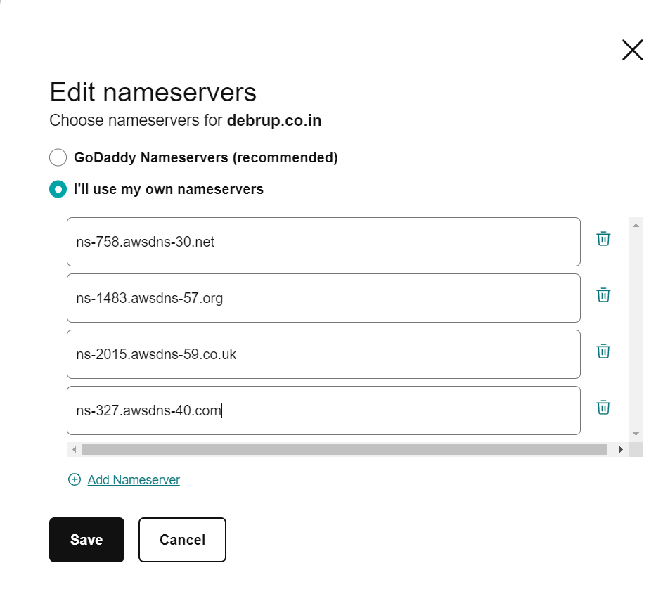

**20. Search from any browser using your domain name with www.**

**21. Append port no. to access the project.**

**Thus,we have successfully run our project using our custom domain-name and URL.**



www.hitesh.co.in:4000